AWS PROJECT

190030236

C . Nanda Kishore Reddy

AIM:- Access Ec2 windows instance using Putty software and convert .PEM file into .ppk file using PuttyGen software.

REQUIRED TOOLS:-

* AWS CONSOLE
* EC2 INSTANCE
* PUTTYGEN SOFTWARE

STEP – 1

* We should start the EC2 Service

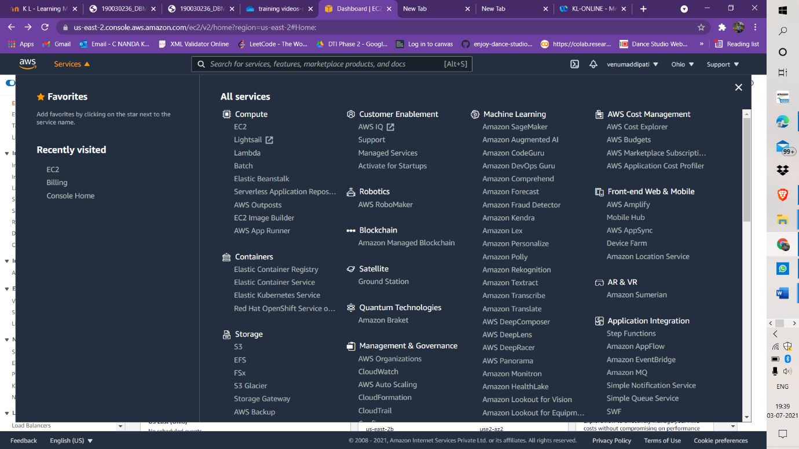

STEP – 2

* We should launch the new instance

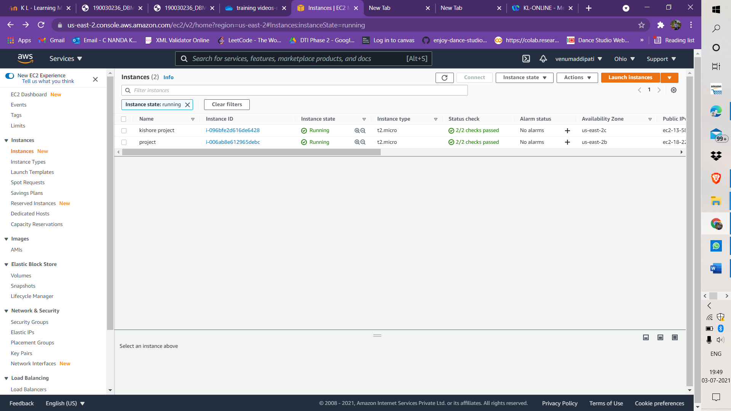

STEP – 3

* WE should choose the AMI
* I Have taken the Ubuntu by my choice

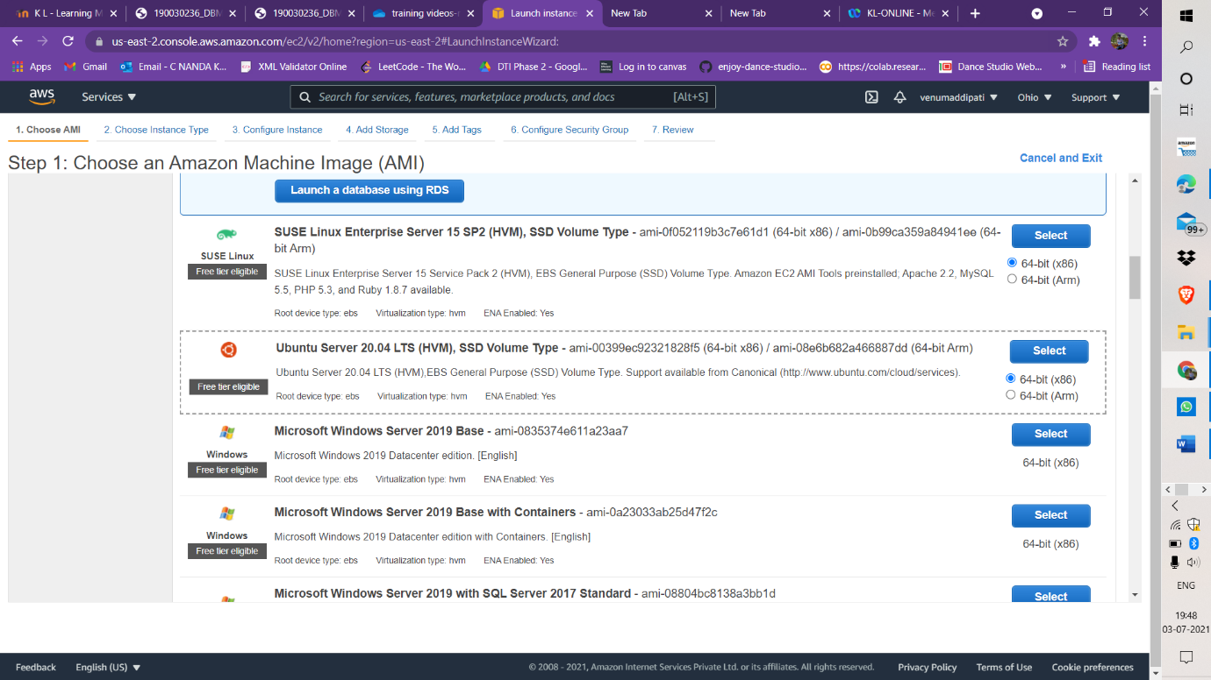

STEP – 4

* We should choose the instance type
* As I have taken the free tier which will be having the limited sources

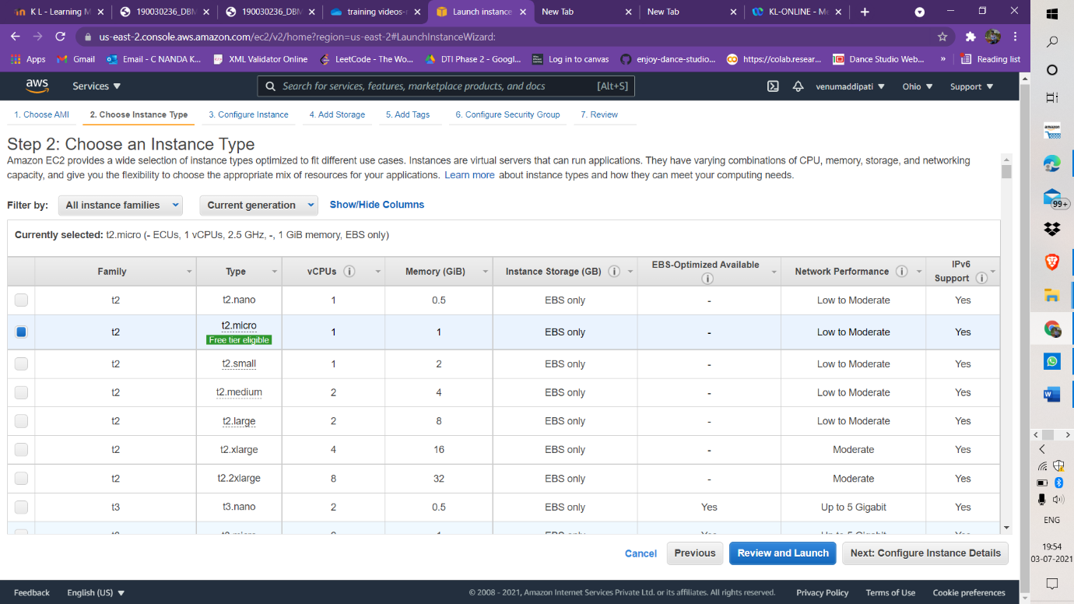

STEP – 5

* I have defaultly did not change the instance details and proceeded with the next step

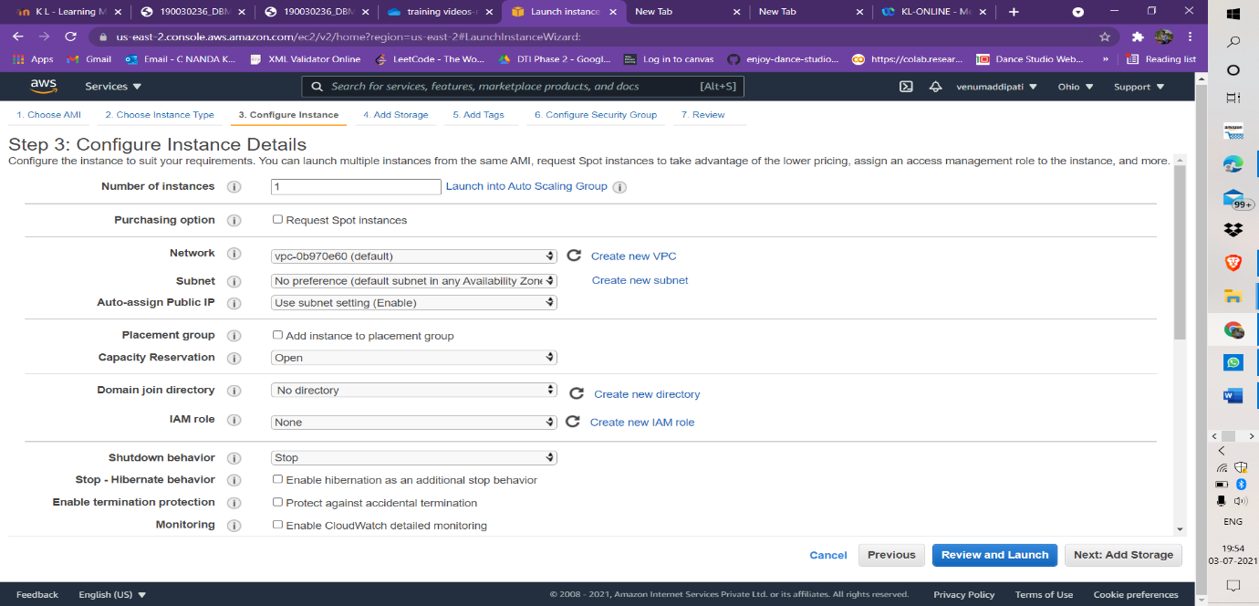

STEP – 6

* I Have proceeded with the further step Add Tags

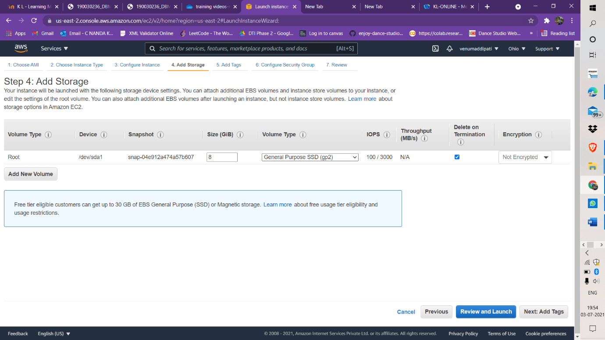

STEP – 7

* We have to add tags if we needed, but I did not added any tags

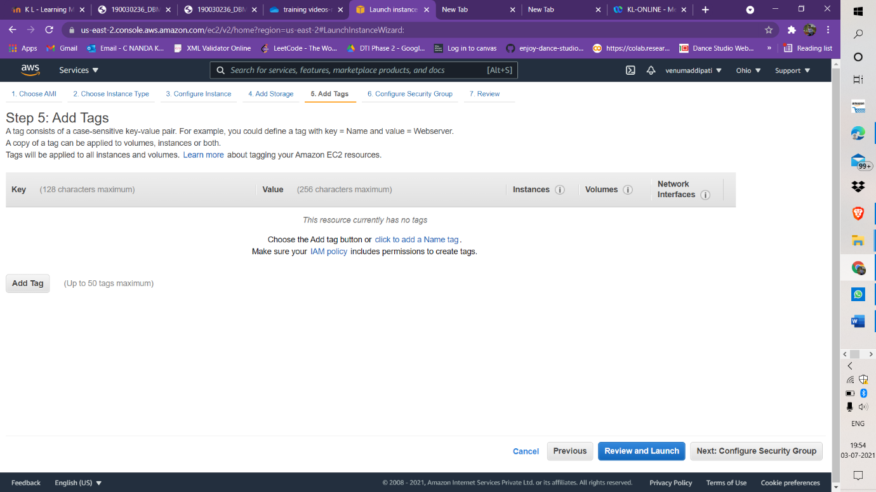

STEP – 8

* We have assign a security group as new security as we are new

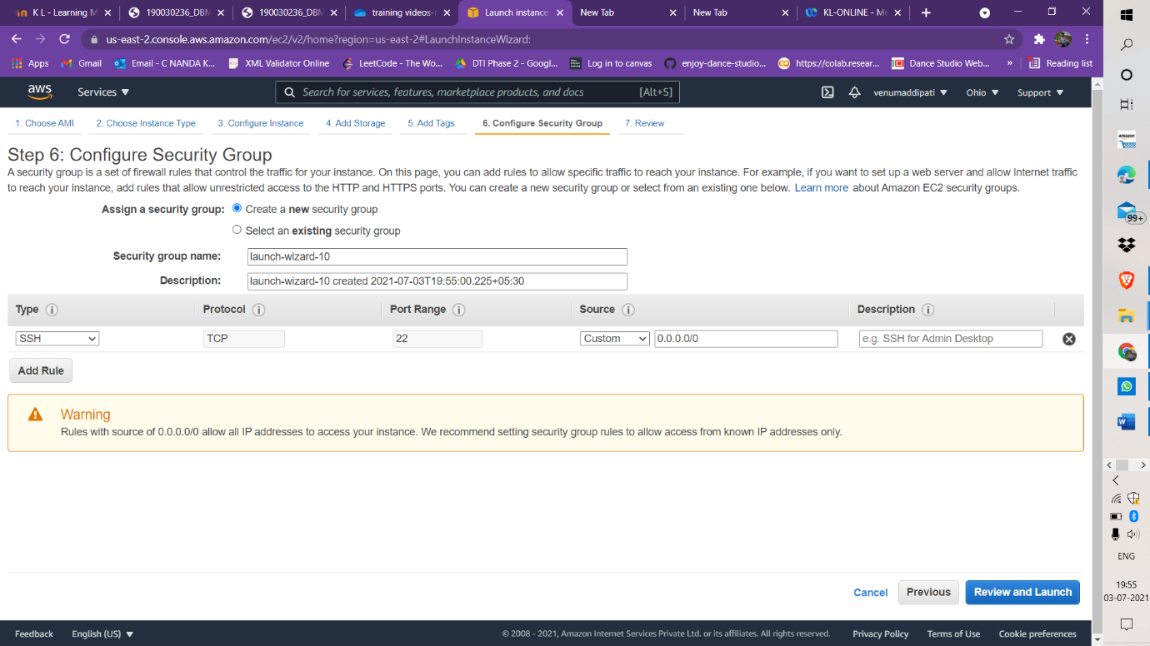

STEP – 9

* At last We have to launch the instance

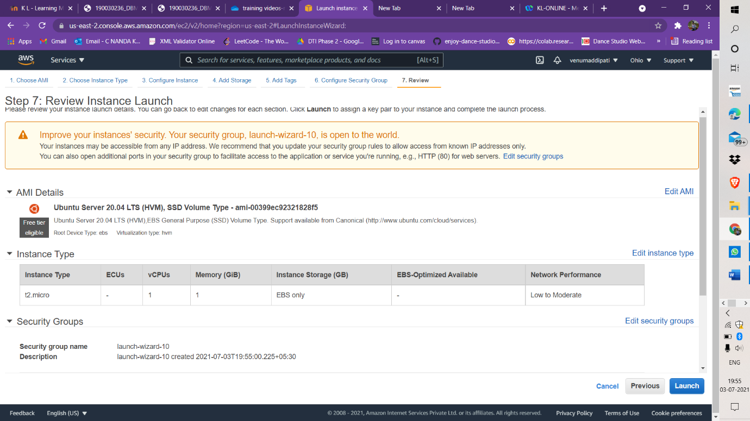

STEP – 10

* WE have to create the new key pair
* As I have given name as KLUNIVERSITIES
* And I have downloaded Key pair
* As it have downloaded with the .pem format

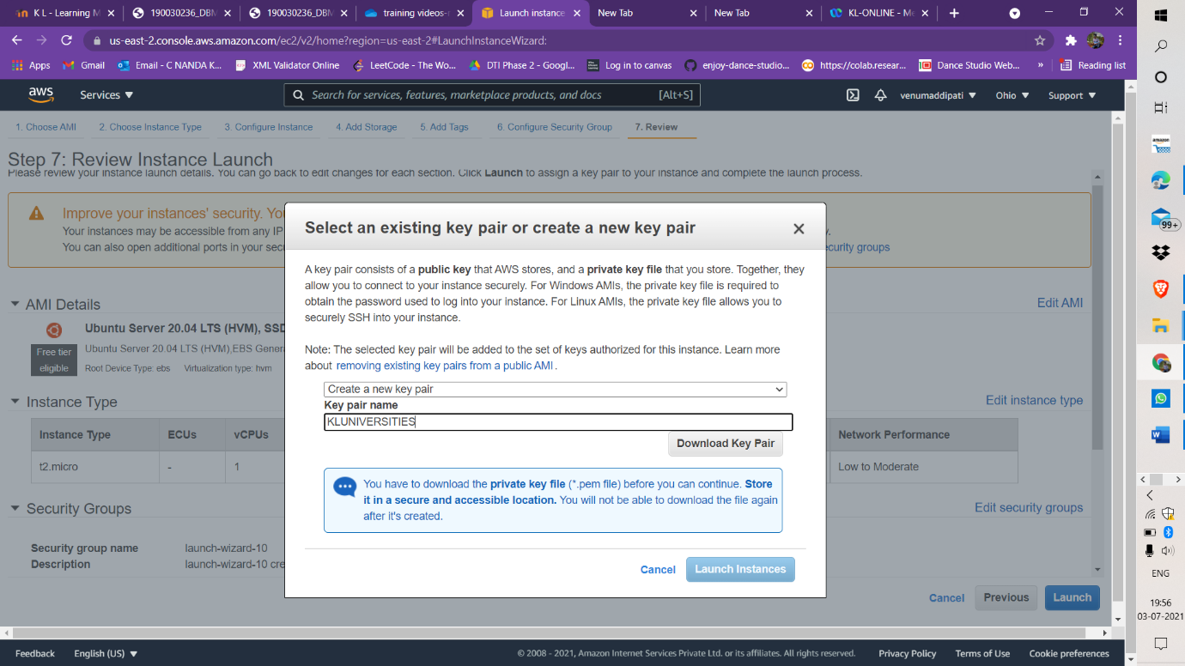

STEP – 11

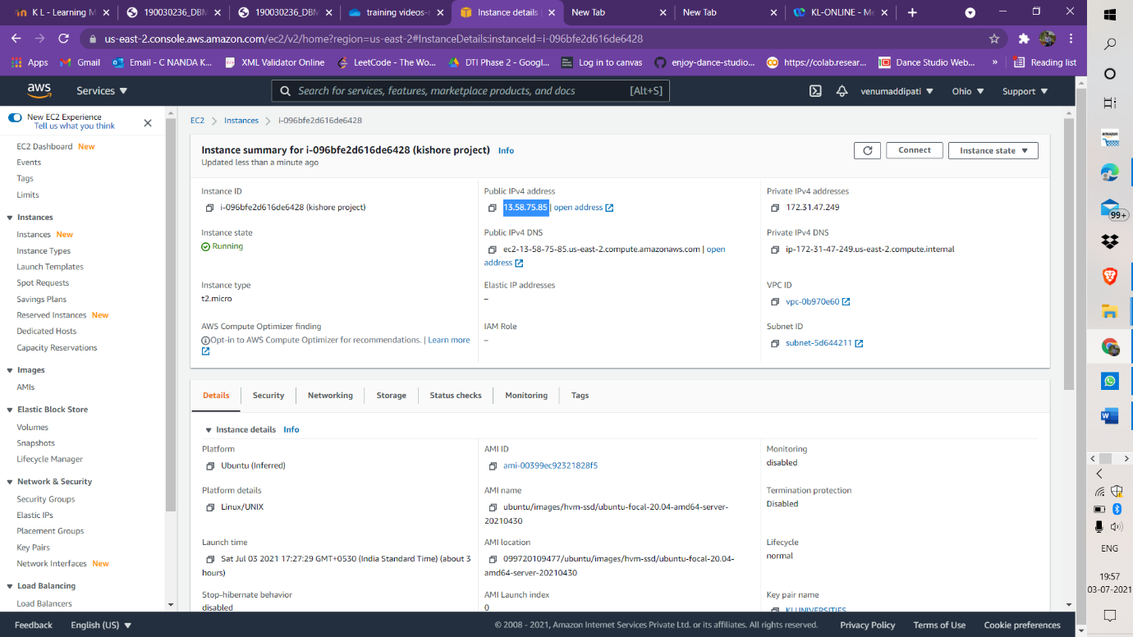

STEP -12

* We should go to puttygen software
* We should go to load private key

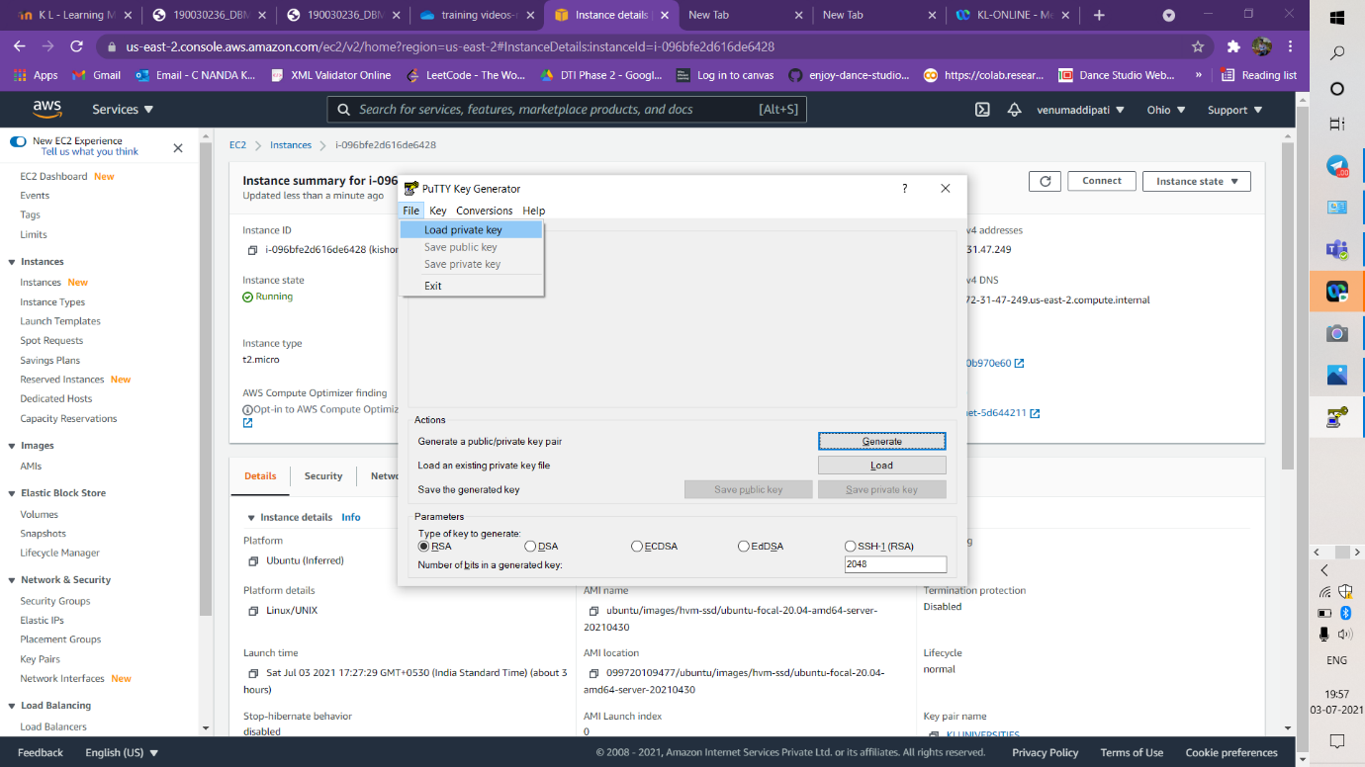

STEP – 13

* I have placed the .pem file and saved as a private key

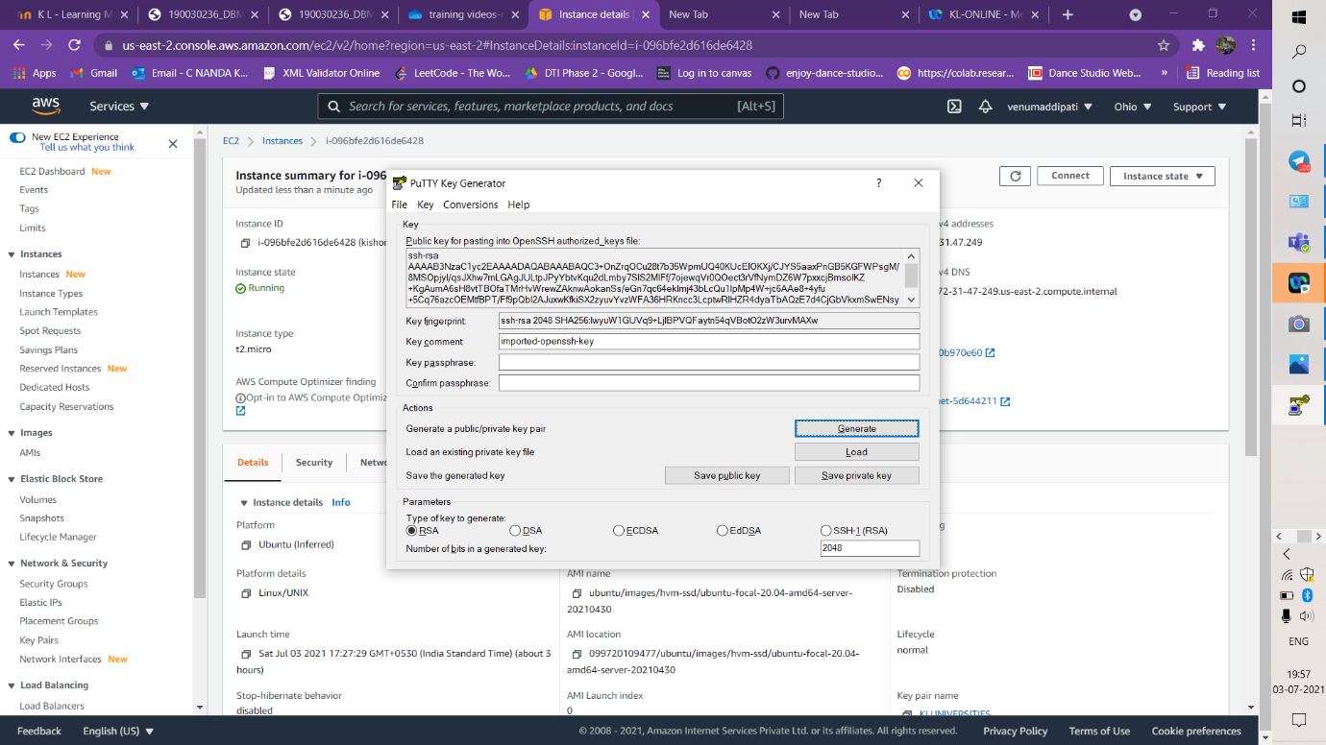

STEP – 14

* We have to place the ip address which is mentioned in step 11

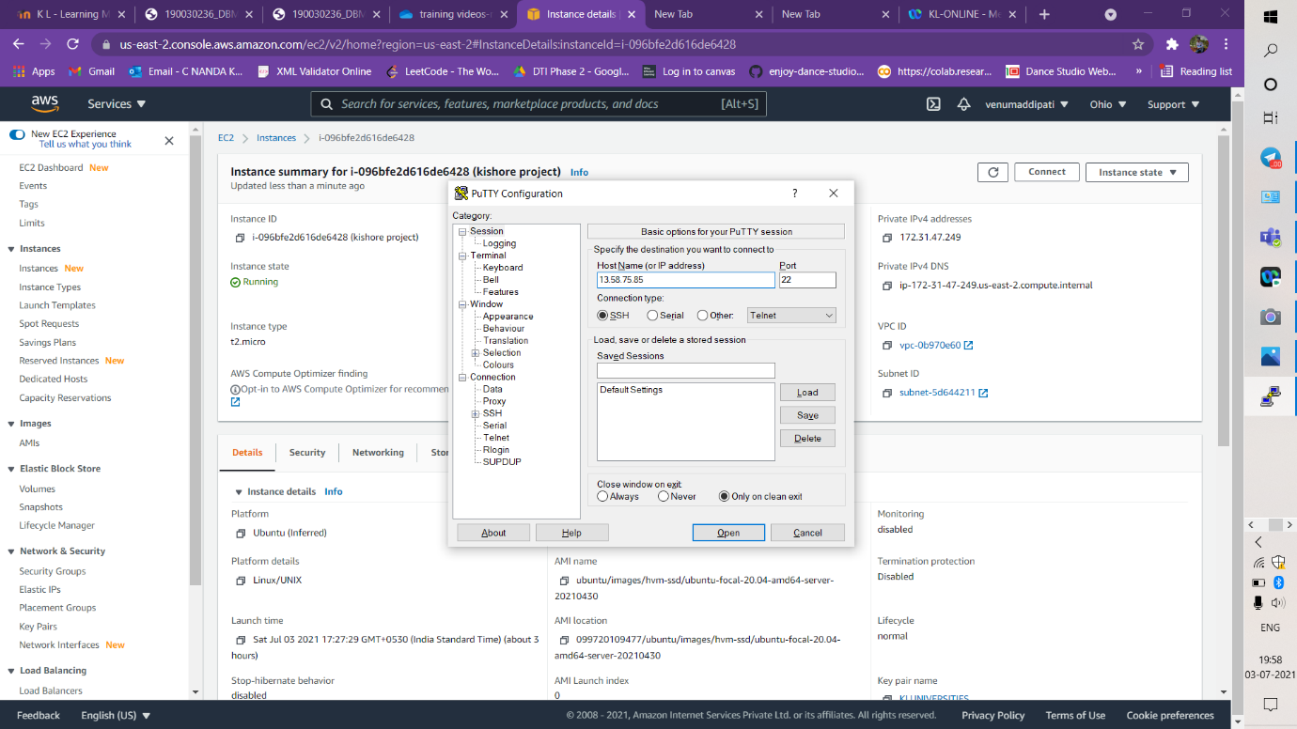

STEP – 15

* We should select the SSHàAUTH and it will ask the .ppk file to upload and Open it

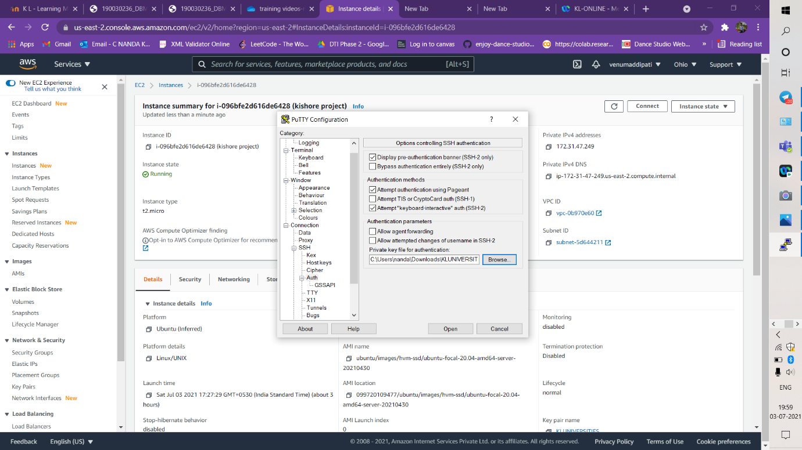

STEP – 16

* And now we will able to access the EC2 - linux

